Deviated well Test Deviated wellpath ,visualization, intersections

Type: Post
Tested functionality: Deviated Wellpath (snaking well)
Model, mesh Horizon/Hexa
Formation: linear
Result: Optimum mudweight
Class: GUI/mechanical
Since GEOMEC version: 3.2

Test description (more detailed)
Automatic selection of points along wellpath
Visualisation of the wellpath linegraph.
Checking snaking up of the well in the graph

Figure model:
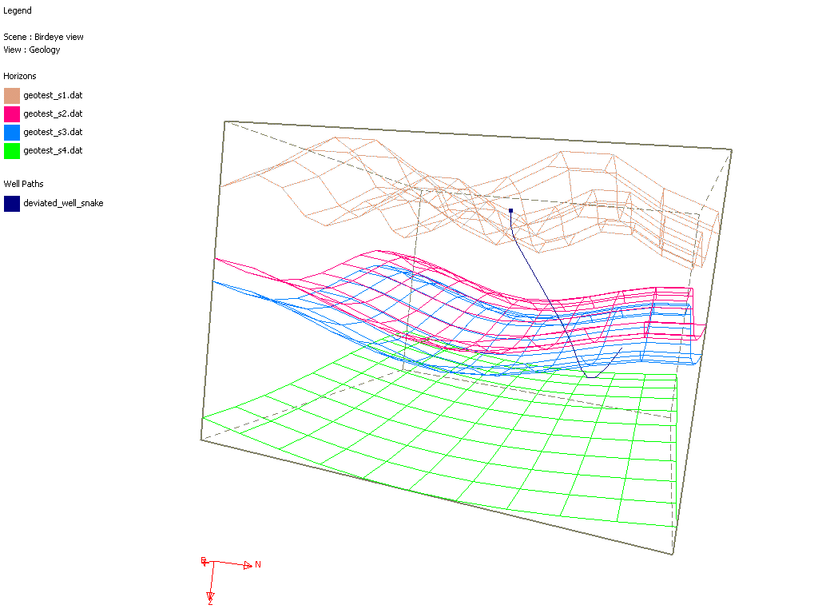

Directories for input and output files:
sourcesafe path: Test/Post/Wellpath/Dstabor ccoupling/deviated wellpath

Results

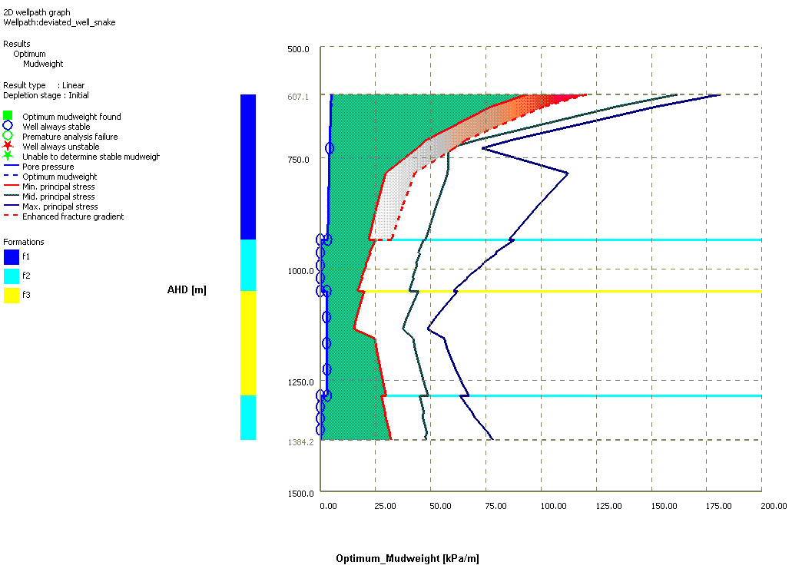
AHD  [m ] | TVD  [m ] | P0 [kPa/m ] | OMW [kPa/m ] | SMIN [kPa/m ] | SMED [kPa/m ] | SMAX [kPa/m ]
728.17 | 472.72 | 4.23 | 4.23 | 43.84 | 27.43 | 34.63
933.83 | 599.04 | 3.34 | 3.34 | 21.93 | 28.59 | 51.20
934.03 | 599.18 | 0.00 | 0.00 | 25.19 | 28.04 | 52.67
962.81 | 619.55 | 0.00 | 0.00 | 22.29 | 27.50 | 49.17
991.59 | 640.77 | 0.00 | 0.00 | 20.88 | 28.07 | 46.98
1020.37 | 661.59 | 0.00 | 0.00 | 19.00 | 27.96 | 44.13
1049.15 | 681.46 | 0.00 | 0.00 | 16.83 | 27.39 | 40.92
1049.35 | 681.60 | 2.93 | 2.93 | 19.97 | 30.32 | 42.45
1108.13 | 712.46 | 2.81 | 2.81 | 16.45 | 28.01 | 37.29
1166.91 | 708.33 | 2.82 | 2.82 | 25.06 | 30.06 | 40.20
1225.69 | 672.54 | 2.97 | 2.97 | 27.30 | 30.50 | 41.26
1284.46 | 630.07 | 3.17 | 3.17 | 29.78 | 30.76 | 42.39
1284.66 | 629.91 | 0.00 | 0.00 | 27.64 | 28.37 | 39.84
1310.11 | 609.92 | 0.00 | 0.00 | 28.78 | 28.25 | 40.82
1335.55 | 589.94 | 0.00 | 0.00 | 29.71 | 27.45 | 41.48
1360.99 | 569.96 | 0.00 | 0.00 | 31.06 | 27.31 | 42.61
1386.43 | 549.97 | 0.00 | 0.00 | 32.24 | 26.44 | 43.38

